**Law of Sines** Name:______________________________________

The Law of Sines is important because it can be used to solve problems involving non-right triangles as well as right triangles.

Part I

**Investigation**

1. Open the Geogebra file called LawofSines.ggb.

Consider acute triangle ABC.

1. Measure angles A, B, and C.
2. Measure the lengths of a, b, and c.
3. Measure the Sine of A, B, and C. Create a label for them.

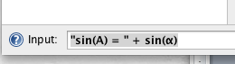

Type in the function bar:

“Sin(A) = “ + sin(α)

Use the algebra view on the left side of your Geogebra file to find which Greek letter goes with angles B and C. for Example: β or γ. *(Hint: if you double click on the greek letter, it will tell you the angle it measures)*

Follow this logic to label the measurements of sin(B) and sin(C).

Your Geogebra file should look something like this:

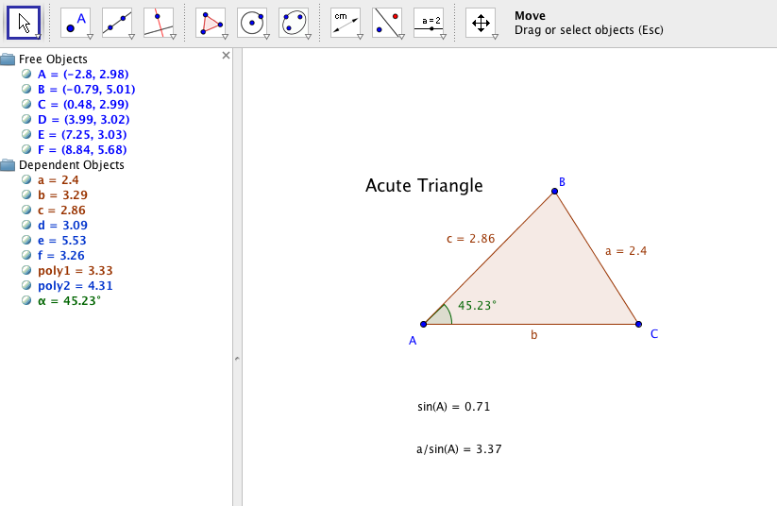

Algebra View

Recorded Information

Calculate , , . Record these on your Geogebra file.

***Pause!***

**Poll Everywhere Questions:**

1. What do you notice about these ratios?
2. Wiggle the points on your triangle, what happens to these ratios?

**Save your Geogebra file in the format:**

**LastNames_LawofSines.ggb**

**The Law of Sines -- Definition**

‘

**Practice**

### http://www.mathsisfun.com/algebra/images/trig-sineruleex2.giftriangleFind "c” 2. Find “b”

***Pause!***

Part II

**Proof!**

We have just investigated and seen the power of the Law of Sines! Now we will formulate a proof that holds true for *all* triangles.

There are two components of the proof: One for acute triangles and one for obtuse triangles. We have to complete both!

Open the Geogebra file Proof.ggb. Answer the questions on the Geogebra file by creating text boxes and placing them appropriately.

***Verify the answers you provide by using the given triangles for calculations and then wiggling your triangle***

**Save your completed Geogebra file in the format: Lastnames_Proof.ggb**

**Upload your Geogebra file:**

1. Go to [www.dropitto.me/msnardini](http://www.dropitto.me/msnardini)
2. Enter password: mathrocks
3. Upload your two files! Make sure they are named correctly!

**Poll Everywhere Questions**

1. What 3 pieces of information do you need to solve a problem using the Law of Sines?
2. Why are the sines of two supplementary angles equal?