What path will your bird take?

Name:_____________________________



**Part One – Red Bird**

1. Go to <http://nardinitech.weebly.com/tech-project.html>
2. Under student materials, open the first Geogebra file called Red Bird.
3. Recall the general equation of a quadratic formula below.



With your partner, discuss how each variable can change the graph of a quadratic function. Write down what you remember about how each variable changes the graph of the function.

***Pause!***

1. Create three sliders named a, h, and k.
   1. Make sure the maximum value on the interval for both sliders h and k are **20.**
   2. Change the Interval to **.025** for all three sliders.

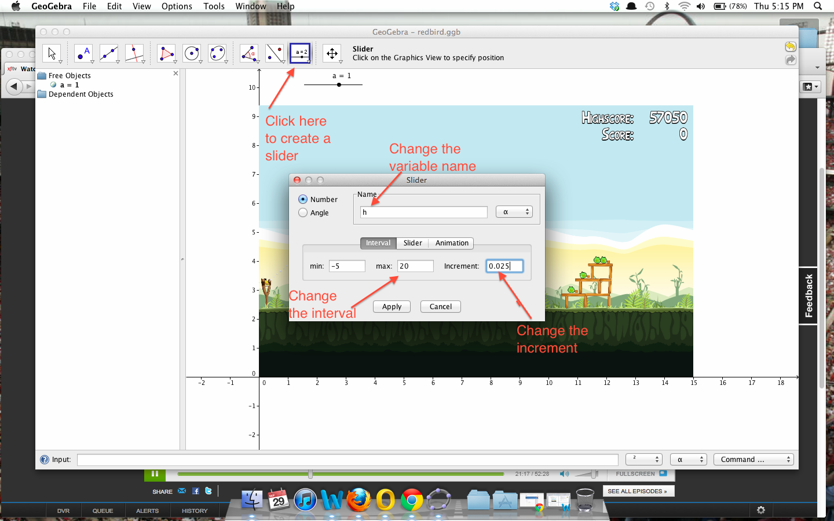

1. In the input bar, type in the equation: 



*\*Note:* Remember to add a space between the variable a and the open parenthesis to denote multiplication. *

1. Manipulate the sliders a, h, and k until you find a graphical representation of the red bird’s flight path. (**Hint**: You can type in a = ____ into the input bar to change a to a specific value. This applies to h and k too! **Hint 2**: You can also click on the slider and use the arrows to get a more precise graph!)
2. Write the equation of your graph below. Have your teacher initial here: ___________

***Pause!***

**Part Two – Yellow Bird**



1. Go back to <http://nardinitech.weebly.com/tech-project.html>
2. Open the second Geogebra file called Yellow Bird.
3. What happened to the yellow bird after you click the mouse or hit the screen with your finger?
4. Where on your picture can you see a change in the bird’s path?
5. Work with your partner to find a graphical representation of the path before the smoke cloud. Write the equation below.

G(x) =

1. Create Point A on your graph to represent the smoke cloud. Make sure it is on the graph of G(x).
2. For what x values is the yellow bird traveling along G(x)? (Hint: There should be a starting x and an ending x value)
3. What function did you find to represent the path after the smoke cloud?

P(x) =

1. For what x values is the yellow bird traveling along P(x)? (Hint: There should be a starting x and an ending x value)
2. What is the value of X at the smoke cloud?
3. Is the bird on the path of G(x) or H(x)?

***Pause!***

**We have just discovered a ___________________________________________!**

: A function that is defined on a sequence of intervals.

**Domain:**

1. What is the domain of G(x)? Write it in both forms. (Hint: Think back to question 13)
2. What is the domain of H(x)? Write it in both forms. (Hint: Think back to question 16)

Let’s formalize the equation of the path that our yellow bird flew.



1. Now let’s graph your piecewise function on your Geogebra sketch by using the input bar. Here is an example:
2.  If you were graphing G(x) = 1-x with domain (-∞, 1] , you would type in the input bar:

Have your teacher initial here: ___________

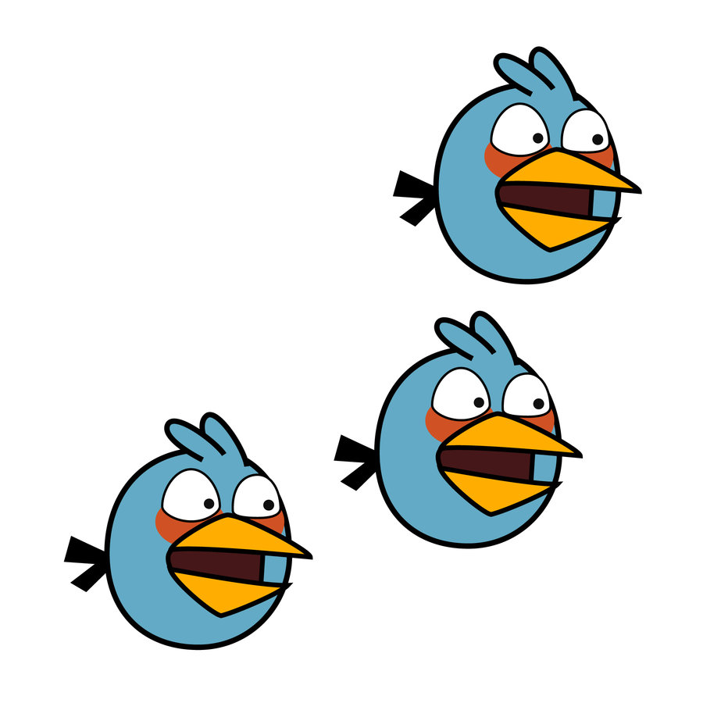

**Part Three -- Blue Birds**

1. Go back to <http://nardinitech.weebly.com/tech-project.html>
2. Open the third and final Geogebra file called blue birds.
3. Remember that after we clicked the mouse, the blue bird changed into three different birds.
4. Using all of the tools we have gathered so far, **you will be creating a piecewise function for each blue bird.**
5. Write your piecewise function for bird one below.



1. Write your piecewise function for bird two below.



1. Write your piecewise function for bird three below.



1. Graph the three piecewise functions.